**7PAM2000-0901-2­022**

**Applied Data Science-1**

**Assignment 1: Visualization**

**Student id: 21080899**

**By: PavanTeja Turaka**

1. **Visualization Methods**

Developing graphical representations of information is referred to as "data visualization." Through the use of graphs and charts, these representations make the derived insights from the data more visible. This procedure assists the presenter in simply communicating material for the listeners to understand and from which they may easily make inferences. Data visualization can be handled using various methods and applications (Diamond and Mattia, 2017). There are lots of visualization techniques. Here we used three types of visualization methods that are described below:

* **Bar Graph:** The traditional bar chart (also known as a bar graph) is another popular and simple technique for displaying numerical data. The categories being compared are shown along one axis of the chart, and the value being compared along the other. Bar length represents the distribution of values across groups.
* **Scatter Plot:** Scatter plots are another main method of data visualization. Points representing data for two variables are placed on the vertical & horizontal axis to create a scatter plot. This kind of data visualization helps display connections between different variables and uncover hidden patterns.
* **Line Graph:** A line graph, sometimes called a line chart, shows a value's progression through time. This line graph has two axes, the horizontal x-axis and the vertical y-axis. Since only positive numbers are of interest in most line graphs, the y-axis and x-axis often meet close to the graph's bottom and left edges, respectively.

1. **Results of visualization**

This section provides the results of the UK Fuel prices dataset [1]visualization. The dataset obtained from the Kaggle about Fuel. Since BREXIT and COVID are two recent significant developments, I thought it would be a good idea to look into the cost of fuel in the UK better to understand the country's political and economic atmosphere. Because of its relative simplicity, this database is an incredible opportunity to practice your exploratory data analysis skills. Because the columns are descriptive in type, the dataset may be analyzed and comprehended very quickly and easily. The only acronyms you have to know are ULSP, which stands for ultra-low sulfur unleaded petrol, and ULSD, which stands for ultra-low sulfur diesel. This dataset visualization used a python tool that contains lots of visualization and importing libraries, so here we used pandas and matplotlib python libraries:

* Matplotlib: One of the charting libraries available in Python is called Matplotlib. Matplotlib makes simple things simple and difficult things achievable.
* Pandas: In machine learning, Pandas is one of the technologies that may be used for data cleaning and analysis purposes. It has capabilities that may be used for investigating, cleaning, altering, and visualizing data in various forms.

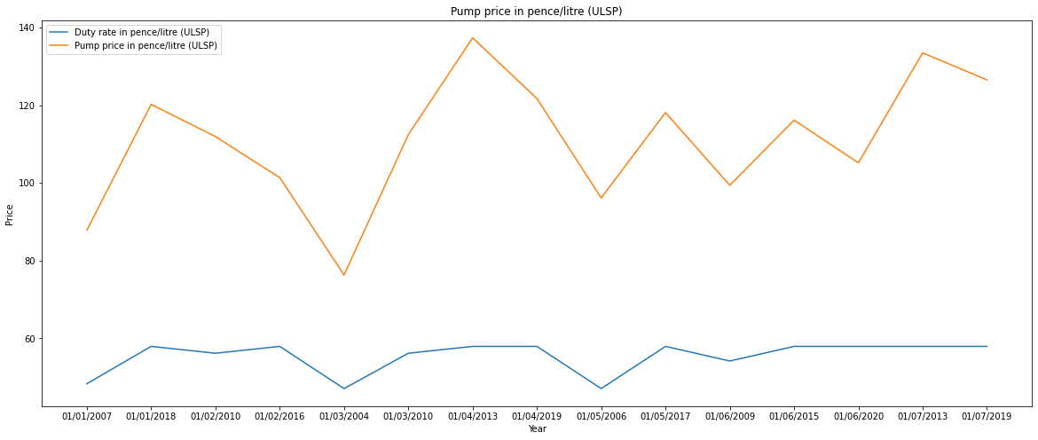

Figure 1: Plotting line graph using matplotlib of Pump price in pence/liter (ULSP)

Figure 1 plotting graph represents the Pump price in pence/liter (ULSP- Ultra-low sulfur unleaded petrol). Figure 1 shows that the cost to operate a ULSP pump began to increase in 2007, with the greatest annual cost occurring in 2013 and the lowest in 2004. The duty on ULSP also fluctuates from year to year.

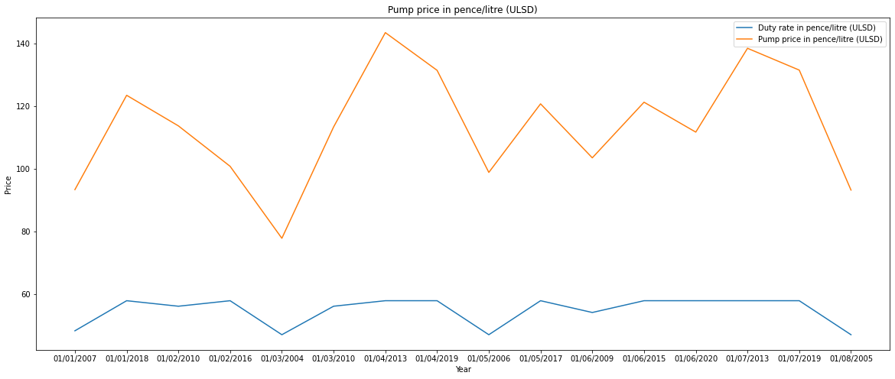

Figure 2: Plotting line graph using matplotlib of Pump price in pence/liter (ULSD)

Figure 2 is a plotting graph representing the pump price in pence/liter (ULSD- Ultra-low sulfur diesel). Fig .2 shows the same phenomenon as Figure 1: pump prices for ULSD begin in 2007 and vary by year, with the greatest price in 2013 and the smallest in 2004. Furthermore, the duty rate for ULSD changes per year.

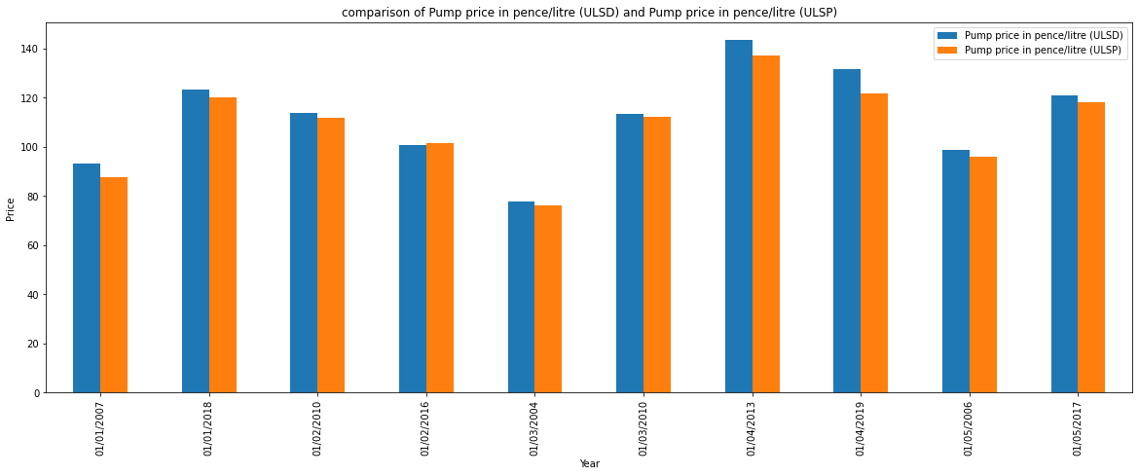

Figure 3: Bar plots for comparison of Pump price in pence/liter (ULSD) and Pump price in pence/liter (ULSP)

The comparison between the VAT percentage rate (ULSP) and the VAT percentage rate (ULSD) is shown in figure 3 in the bar graph that can be seen below. The price of ULSP and ULSD at the pump was at its all-time high in 2013 and at its all-time low in 2004.

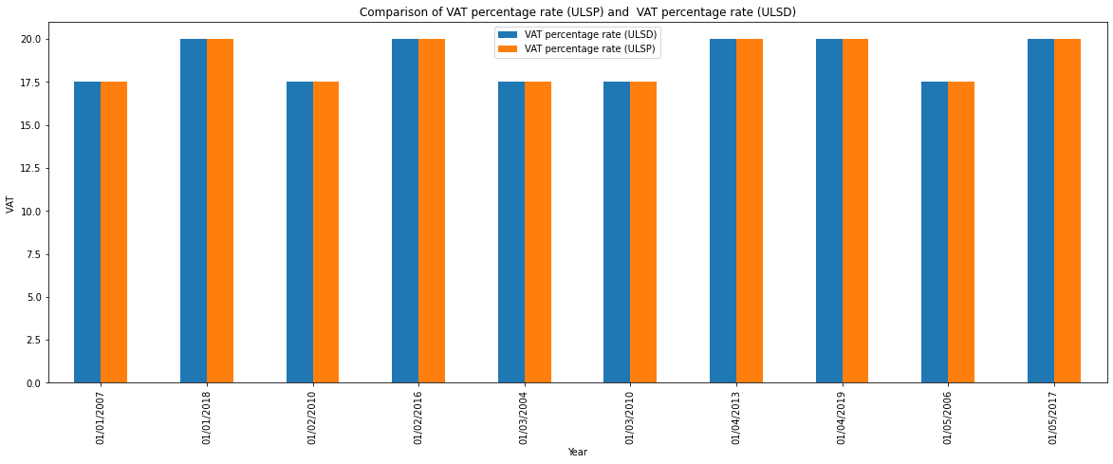

Figure 4: Bar plots for comparison of VAT percentage rate (ULSP) and VAT percentage rate (ULSD)

Figure 4 includes a comparison between the VAT percentage rate (ULSP) and the VAT percentage rate (ULSD), which is represented by the following bar graph. 2013 has the highest VAT percentage rate for ULSP and ULSD, while 2006 has the lowest rate.

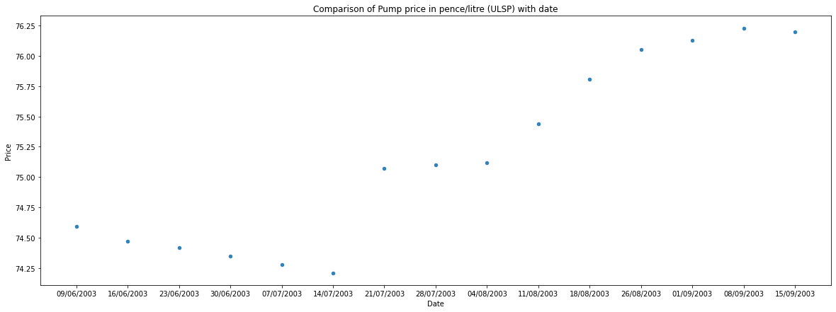

Figure 5: Scatter Plot for comparison of Pump price in pence/liter (ULSP) with Date

The pump price comparison in pence/liter (ULSP) with the Date is shown in the scatter plot in the previous figure, which can be seen above. The x and y axes of a graph reflect the data and the price of the dataset, respectively. The price of ULSP at the pump changes yearly; for example, on June 9, 2003, it was lower than it is now, but on July 21, 2003, it began to rise.

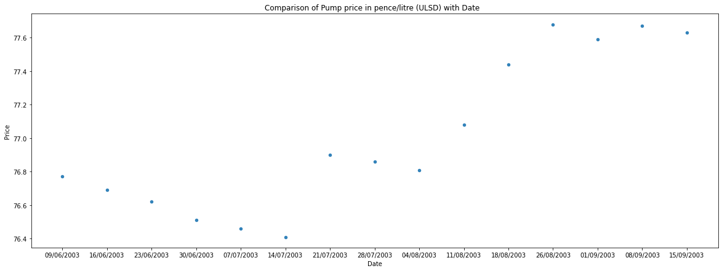

Figure 6: Scatter Plot for Comparison of Pump price in pence/liter (ULSD) with Date

The scatter plot for comparing Pump price in pence/liter (ULSD) with Date is shown in the figure found above. The x and y axes of a graph indicate the data and the database price, respectively. The figure shows how the price of ULSD at the pump varies from year to year, with a decrease on 09/06/2003 and a rise starting 21/07/2003.

1. **References**

Diamond, M. and Mattia, A. (2017) ‘Data visualization: An exploratory study into the software tools used by businesses, Journal of Instructional Pedagogies, 18(1), pp.

1.